# Deploying WAR from JM to another EC2 instance
1.Created Jenkins master and different EC2 instance
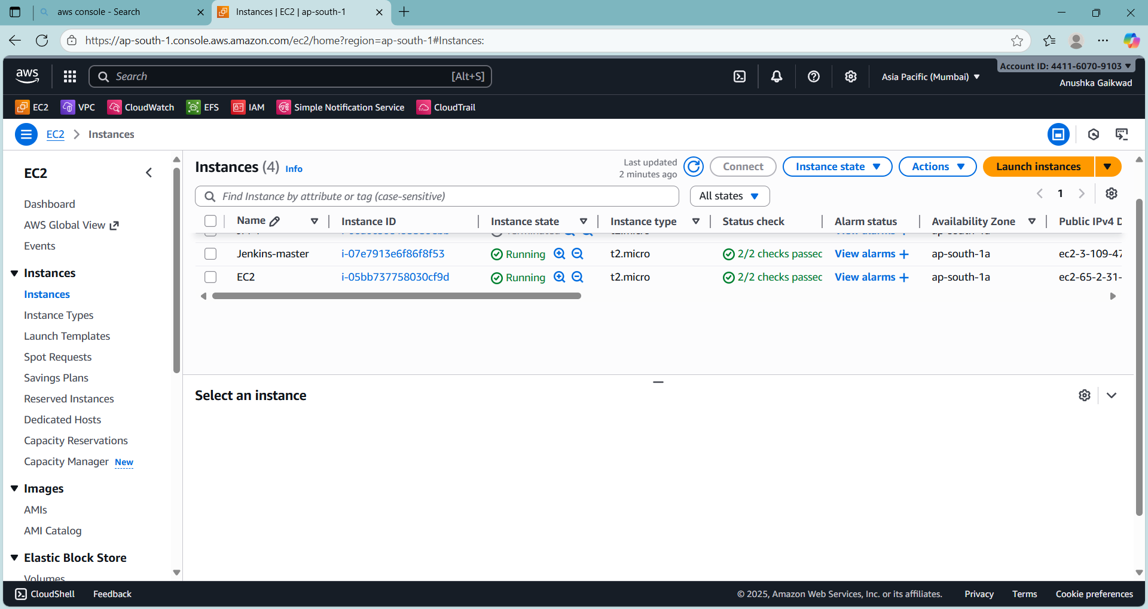
2. on Jenkins master : installed java, integrate maven i.e our WAR file ( LoginWebApp.war ) also integrated git to clone repo
Also on JM deployed Jenkins
And on another hand on our EC2 : installed tomcat and started it
3.created key path in JM for permission issue to another EC2
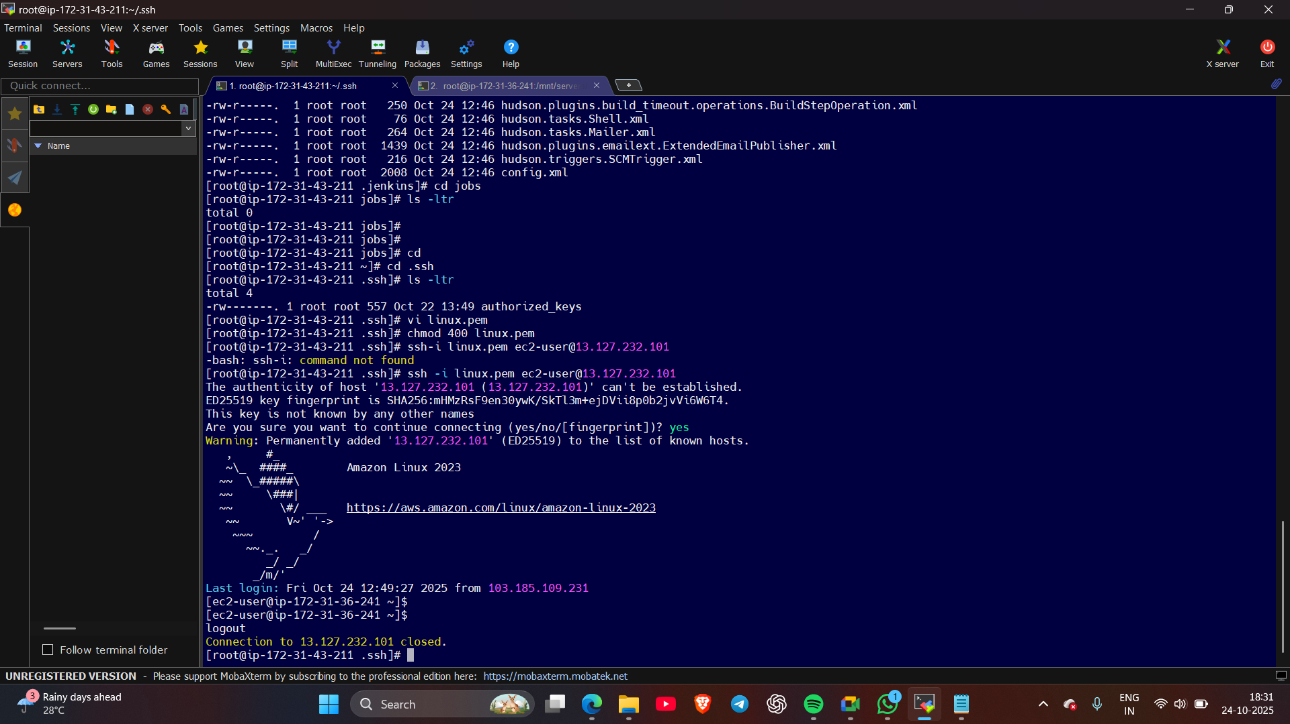
4.sign into Jenkins
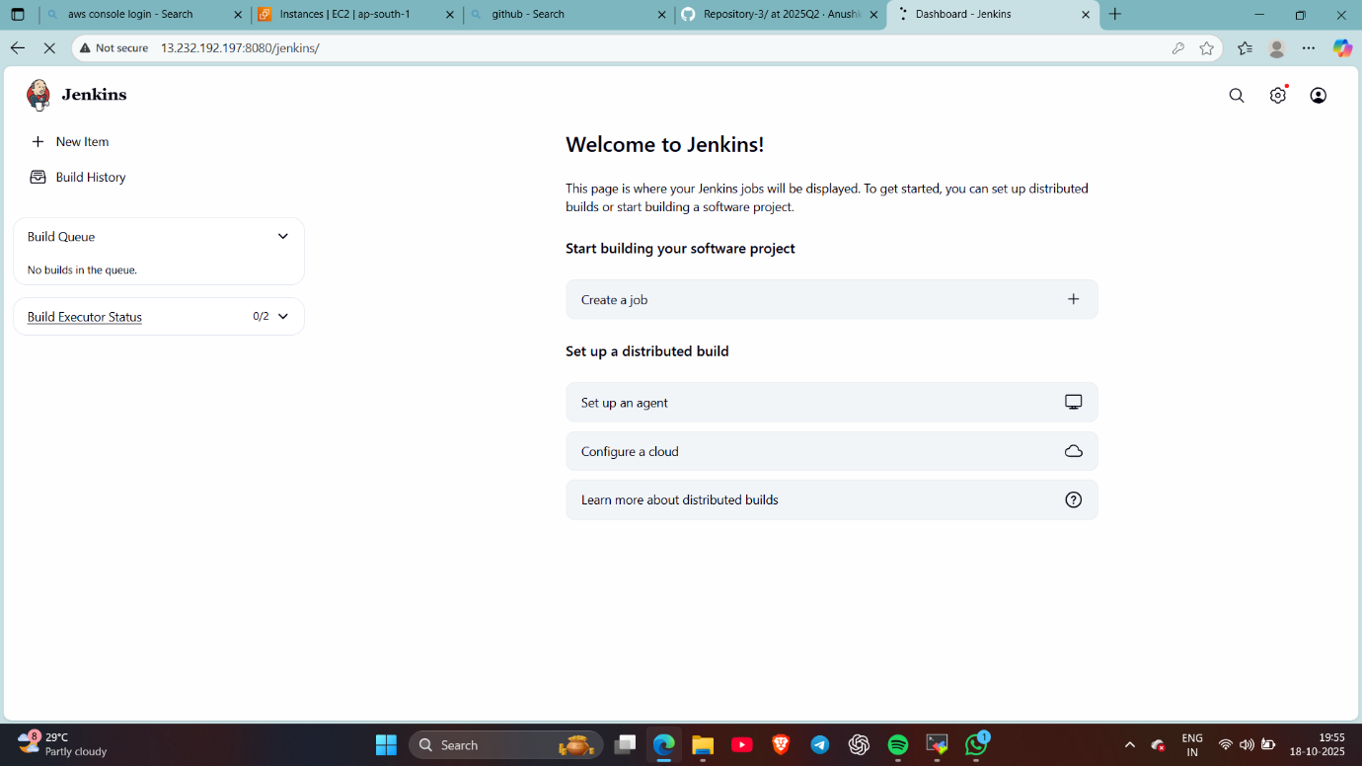
5. installed publish over plugin and configured it by giving access to ec2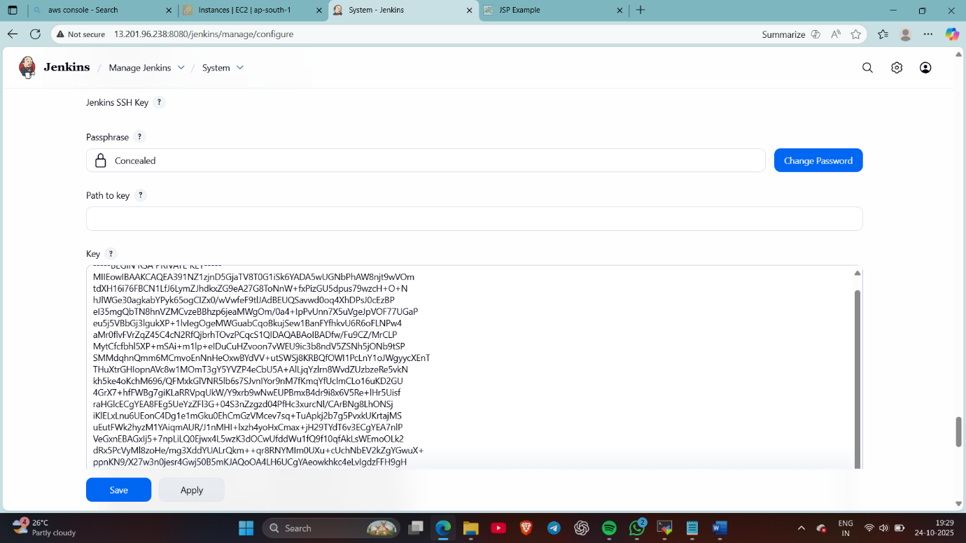
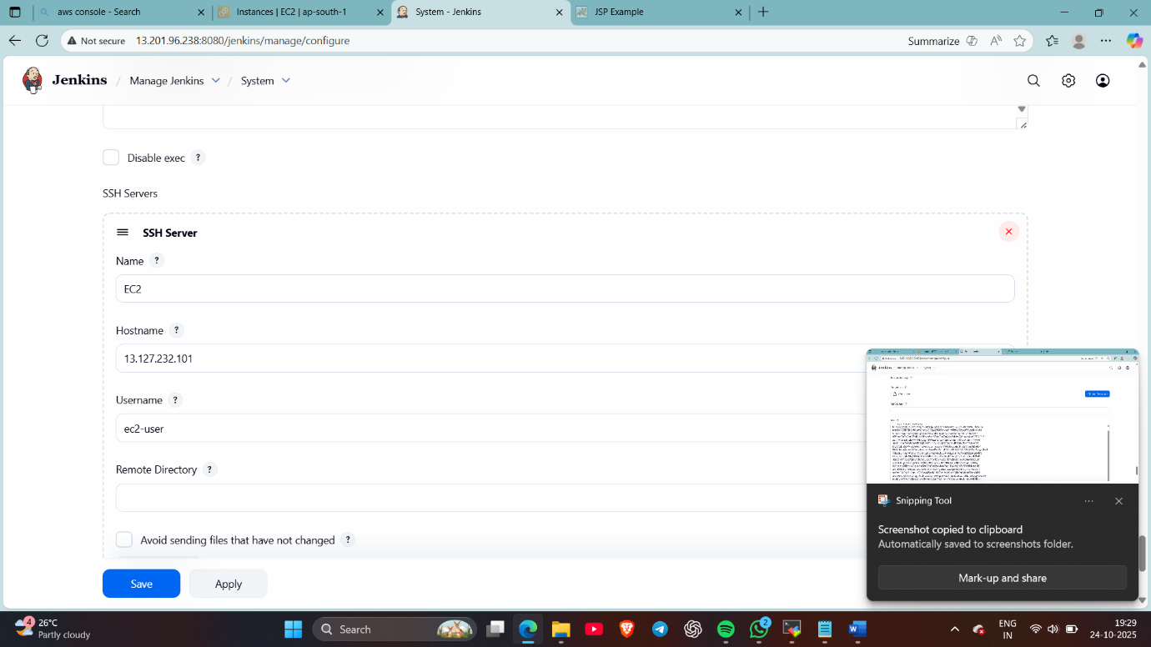

6.create a freestyle job : deploying-WAR-from-JM-to-EC2
Added git repo
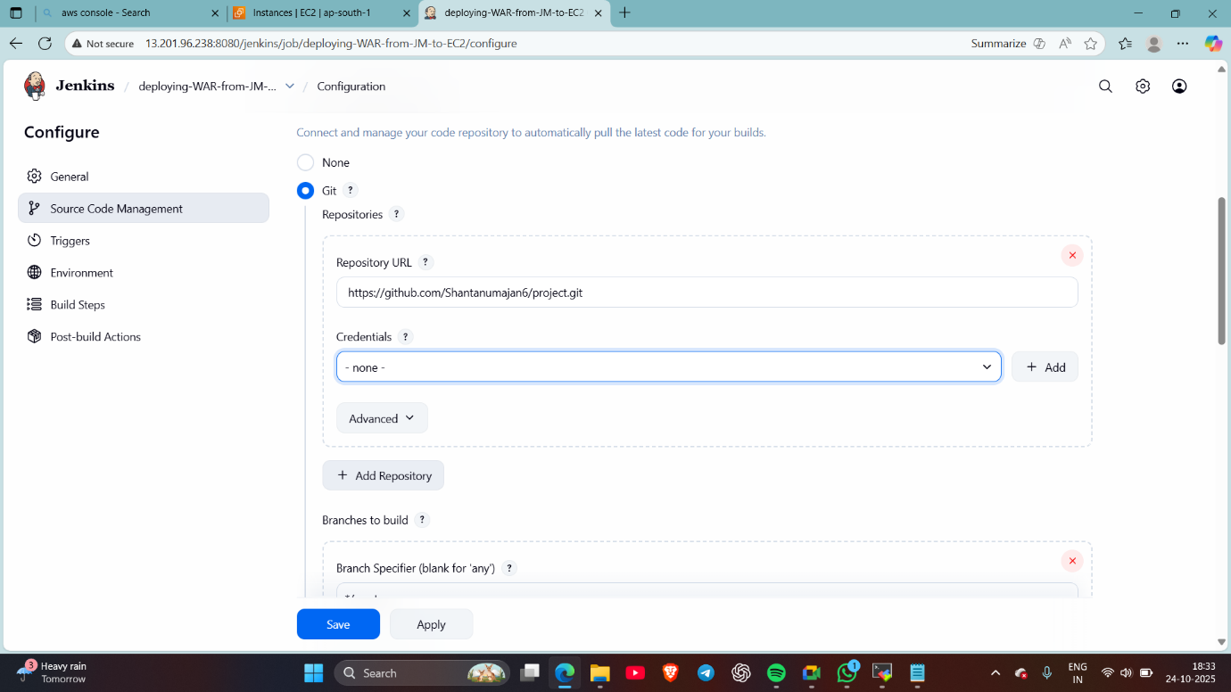
7.selected delete workspace before new job
Also added maven command : clean install (to delete older dependencies)
8. now added shell script to copy our WAR file from JM to EC2
I’ve copied file from workspace to the deployment folder of EC2 i.e webapps
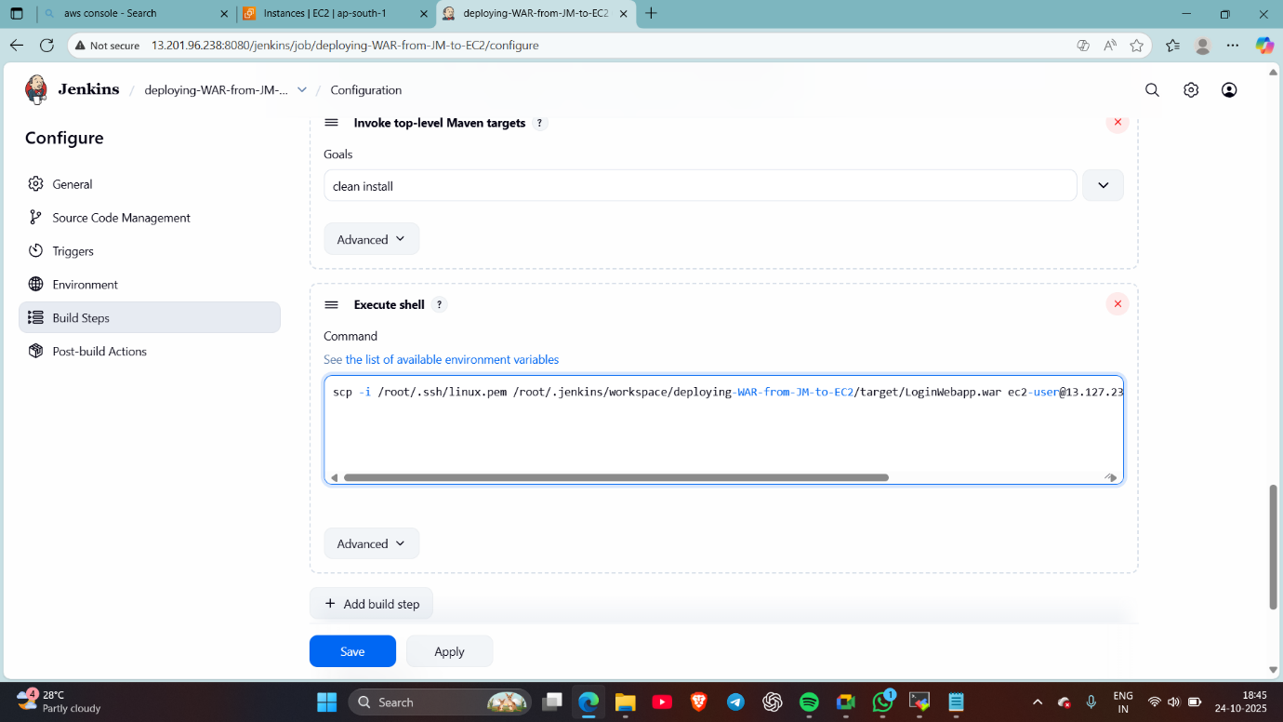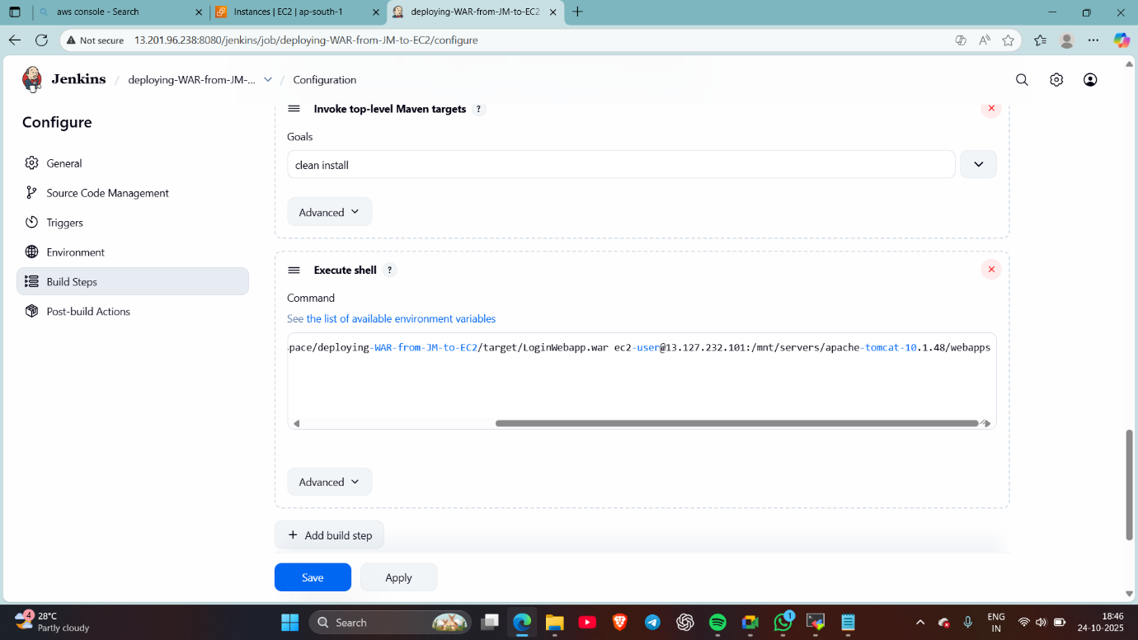

Build a job
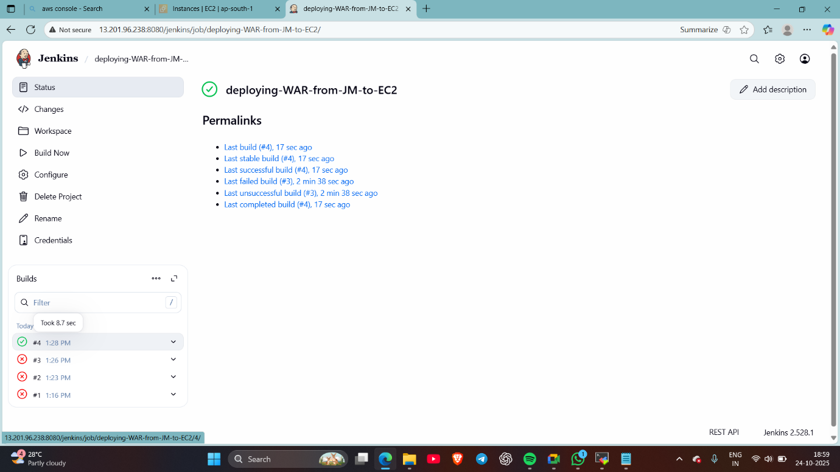
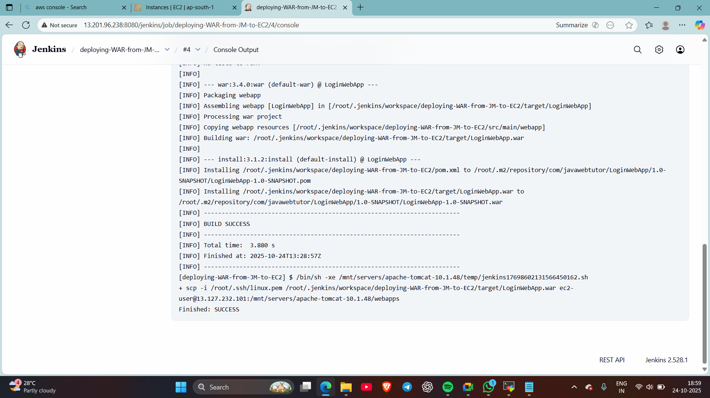

9. checked via browser by another EC2
